Jenkins Setup And Basic Pipe Lines example

Step 1 — Installing JDK:

sudo apt-get update

sudo apt install openjdk-21-jdk -y

Step 2 — Installing Jenkins:

wget -q -O - https://pkg.jenkins.io/debian-stable/jenkins.io.key |sudo gpg --dearmor -o /usr/share/keyrings/jenkins.gpg

sudo sh -c 'echo deb [signed-by=/usr/share/keyrings/jenkins.gpg] http://pkg.jenkins.io/debian-stable binary/ > /etc/apt/sources.list.d/jenkins.list'

sudo apt update

sudo apt install jenkins

Step 3 — Starting Jenkins:

sudo systemctl start jenkins.service

sudo systemctl status jenkins

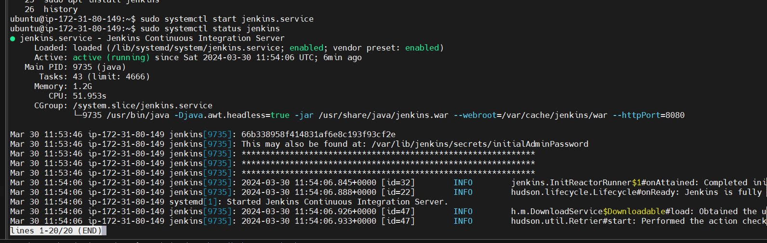

Jenkins is up and running
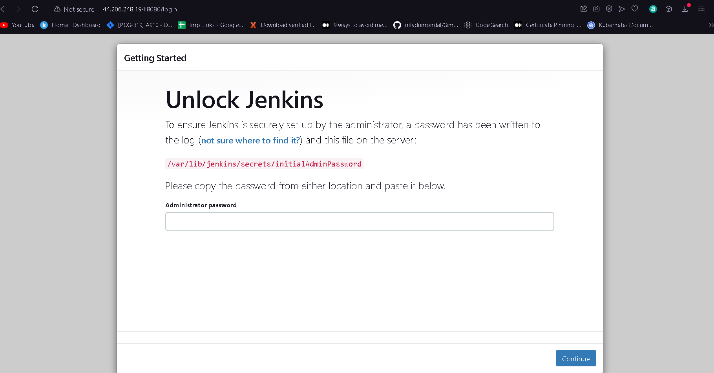

Using sudo command get the initialAdmin password
sudo cat /var/lib/jenkins/secrets/initialAdminPassword

Note you can also use this as script in ec2 instance

#! /bin/bash
sudo apt-get update

sudo apt install openjdk-11-jdk -y

wget -q -O - https://pkg.jenkins.io/debian-stable/jenkins.io.key |sudo gpg --dearmor -o /usr/share/keyrings/jenkins.gpg

sudo sh -c 'echo deb [signed-by=/usr/share/keyrings/jenkins.gpg] http://pkg.jenkins.io/debian-stable binary/ > /etc/apt/sources.list.d/jenkins.list'

sudo apt update

sudo apt install jenkins

sudo systemctl start jenkins.service

sudo systemctl status jenkins

How to add JDK path at manage Jenkins
First go to Manage Jenkins -> Tools Jdk installation add name and JAVA_HOME path
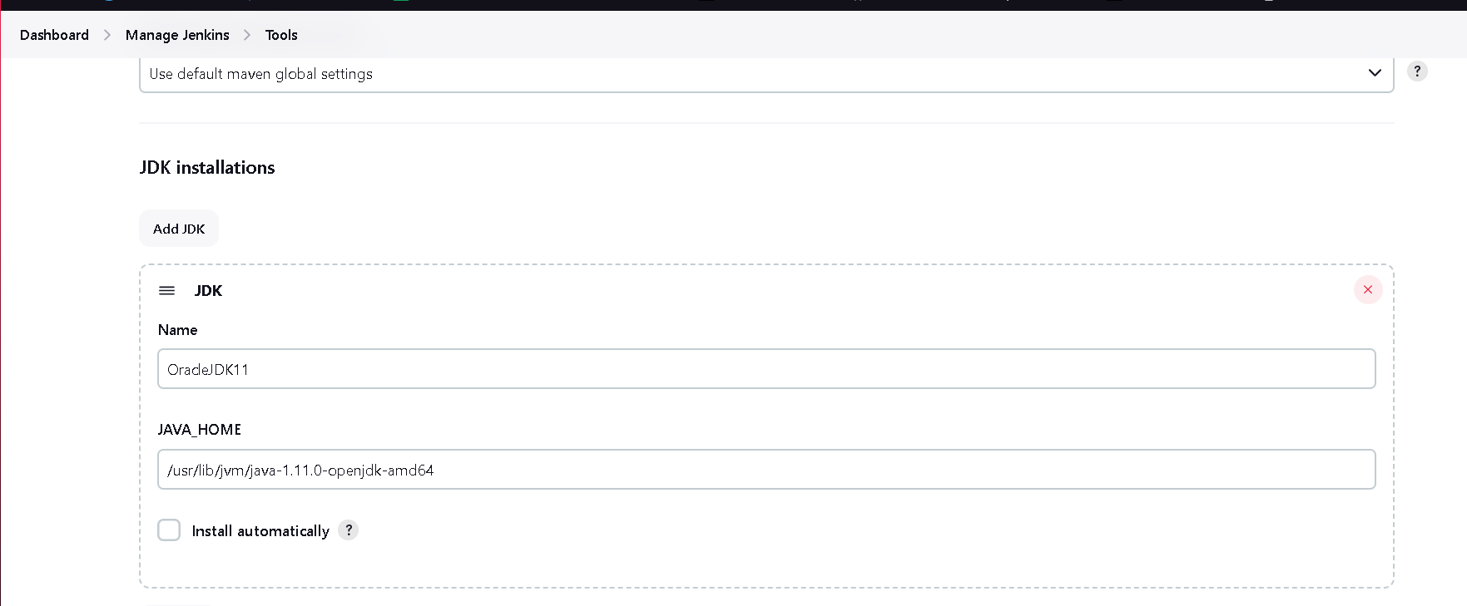
You can add multiple jdk version I am also adding jdk 8 below button add jdk click on it
Before that add jdk 8 in ec2 instance
sudo apt install openjdk-8-jdk -y
add this path in Jenkins jdk
/usr/lib/jvm/java-1.11.0-openjdk-amd64
Add maven as well
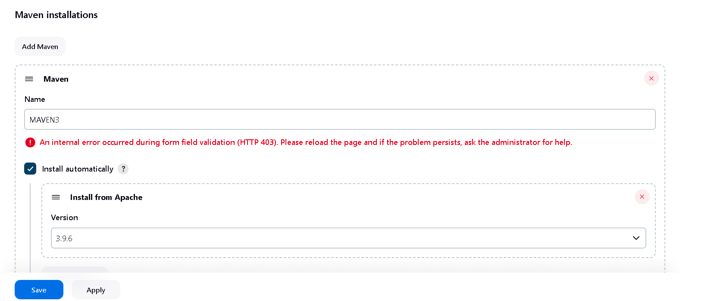
-------RUN Vprofile Simple Maven base Project In Jenkins---------
Step 1: Click on Create New Item then enter the job name and select free style project here
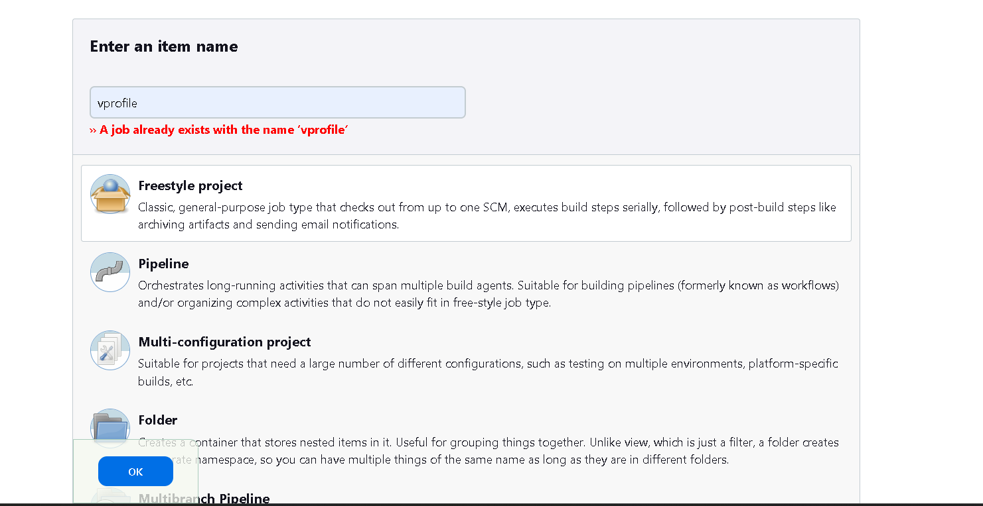

Step 2: Now go to Configuration setting in git add clone url : https://github.com/Abhijeet41/vprofile-project.git
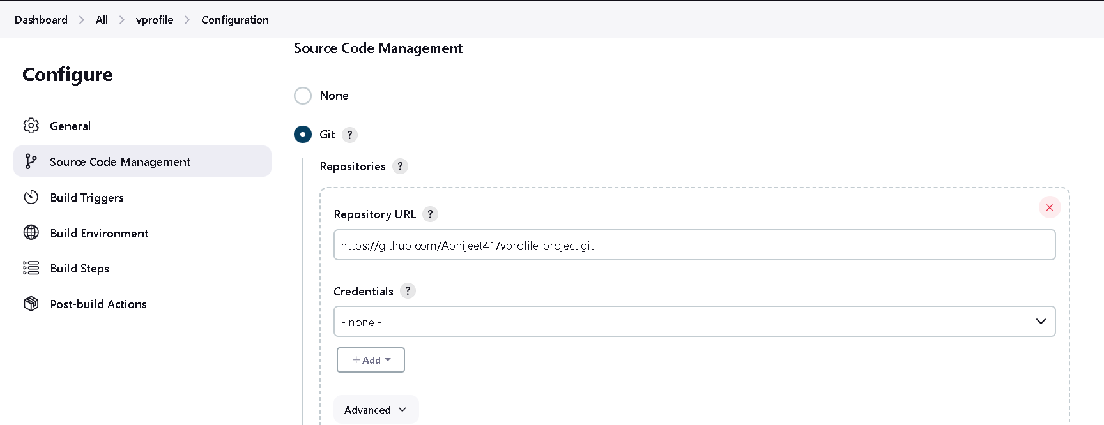
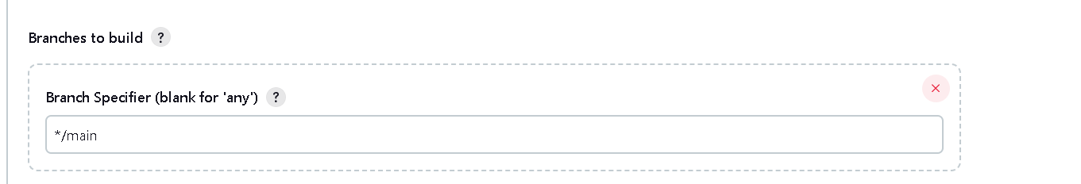
Step3: Go to Build Environment inside build steps Select : Invoke top-level Maven targets set goals
Set Goals as clean install
O/p
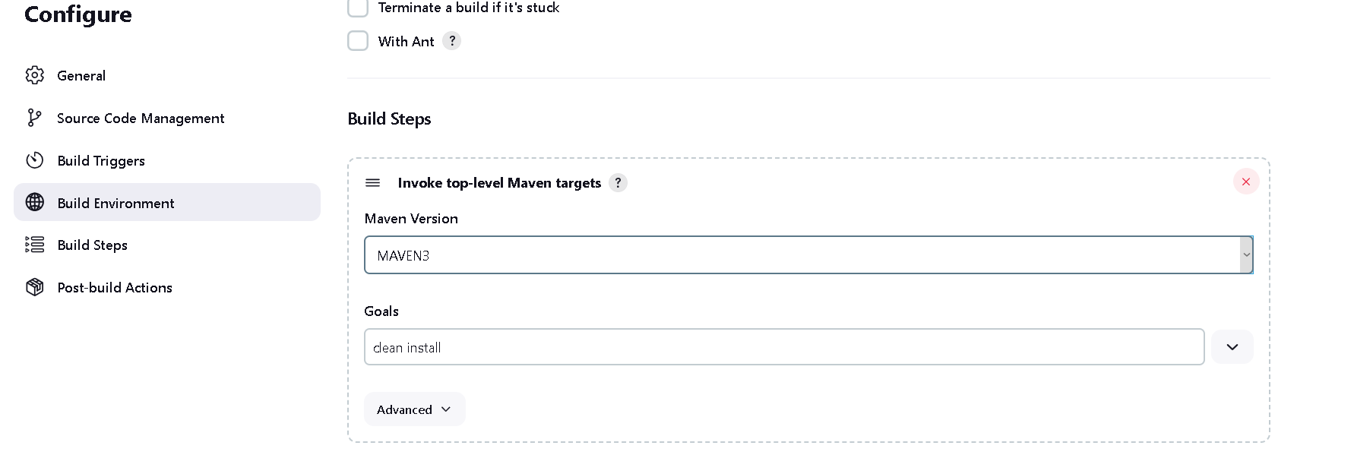

Next post-build Actions is an optional step
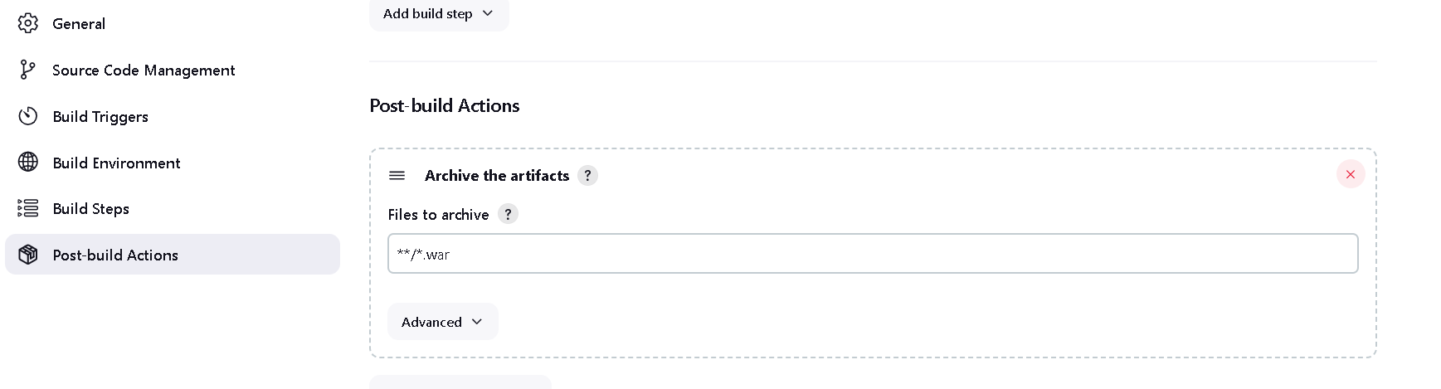

So here is one problem that each time when we build project, new artifact will gets generate each times so the
Previous version of that .war file we lost so to overcome this problem implement versioning

Lets do versioning using Shell Commands
Step1: lets create freestyle project with the name of versioning and below copy from type build i.e existing job
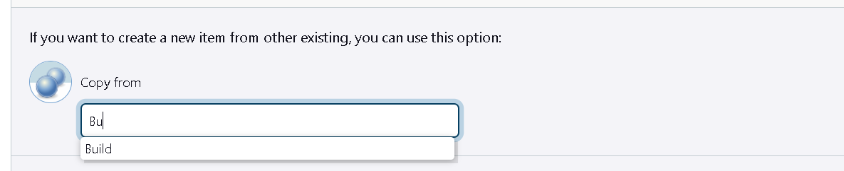
Step2 : run the project and make sure everything is working fine, now go workspace and copy name vprofile- v2.war and in configuration add build step select execute shell
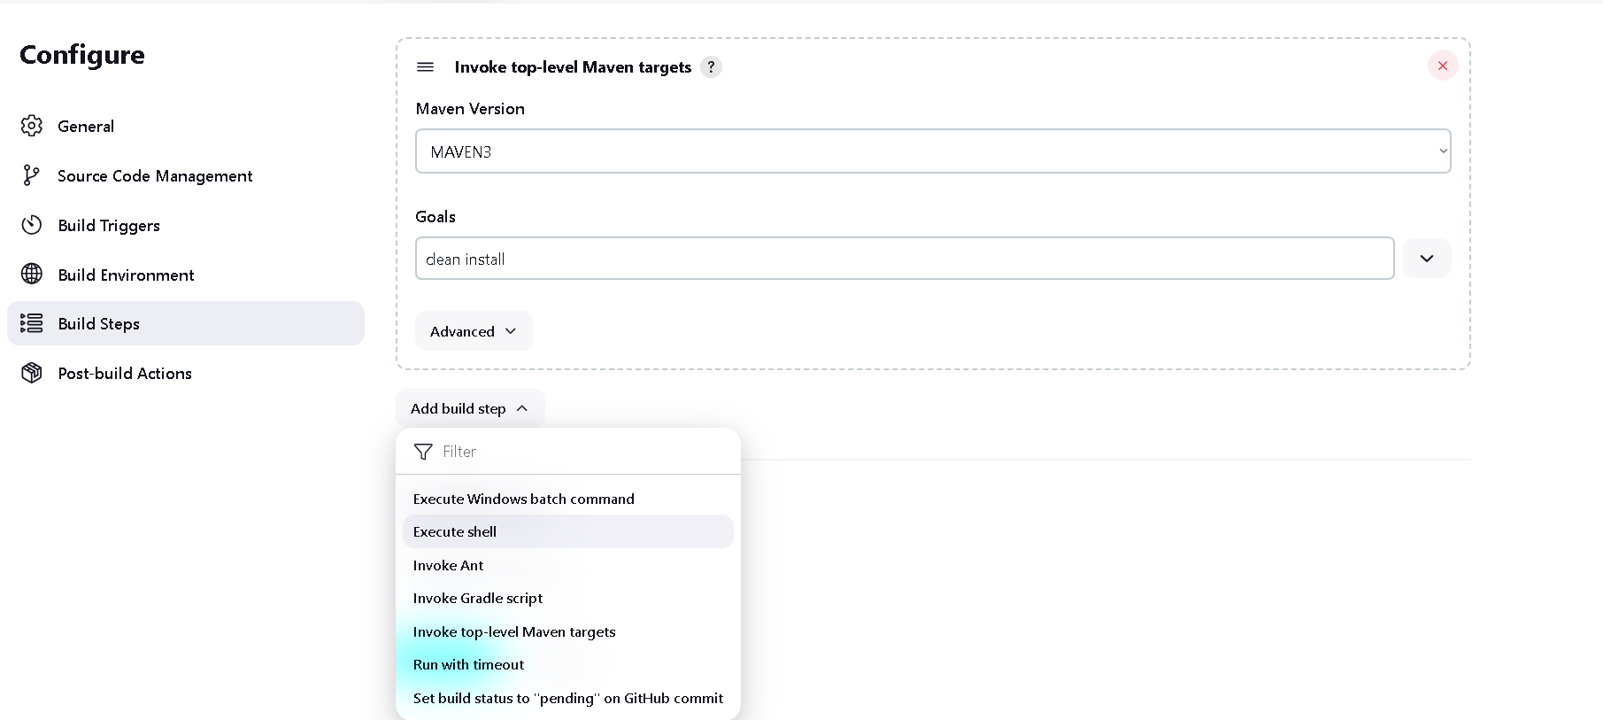

Add following commands
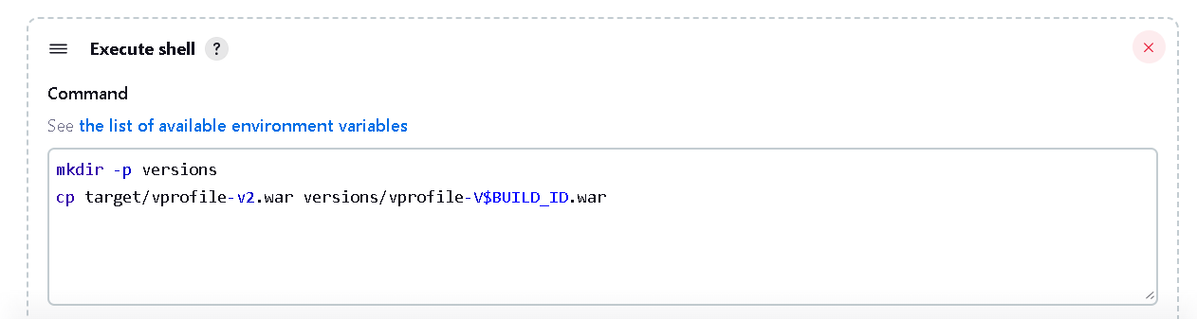

mkdir -p versions
cp target/vprofile-v2.war versions/vprofile-V$BUILD_ID.war
$BUILD_ID is Jenkins environment variable

Ok now save this and to see the output of different versions of war file run project multiple time

So as you can see in workspace there is a versions directory gets created
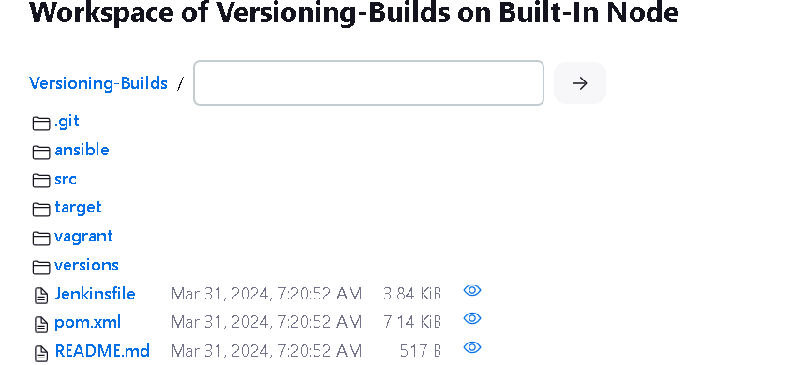

Inside that there is different different versions of .war file
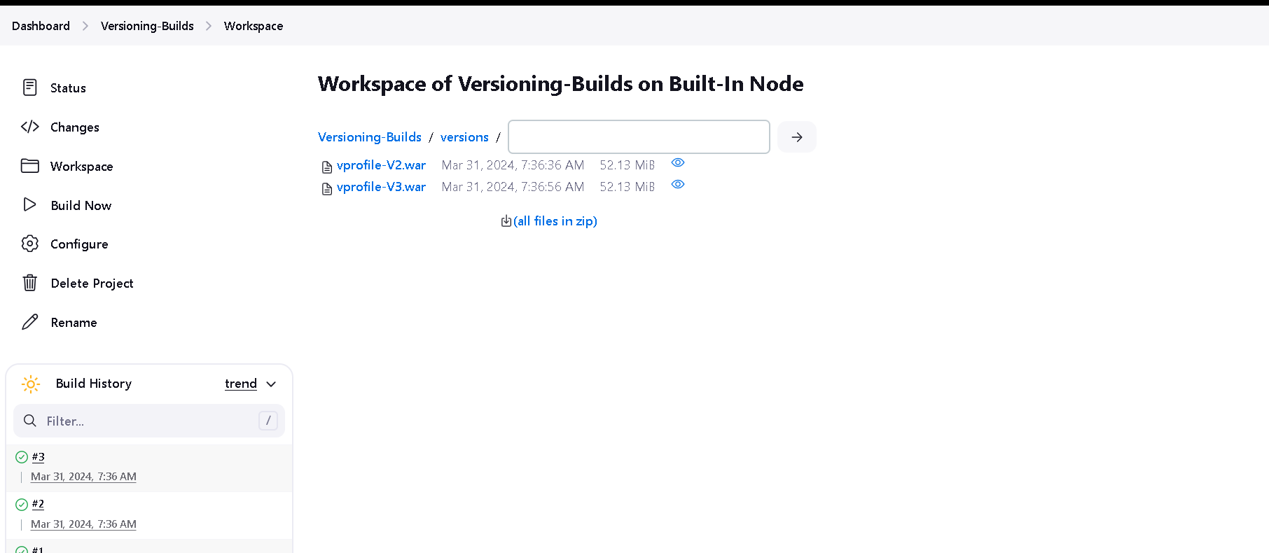

There is slight improvisation we can do this with using parameterized variable name
So in general checkmark the This Project is parameterized and click on add and select string parameter

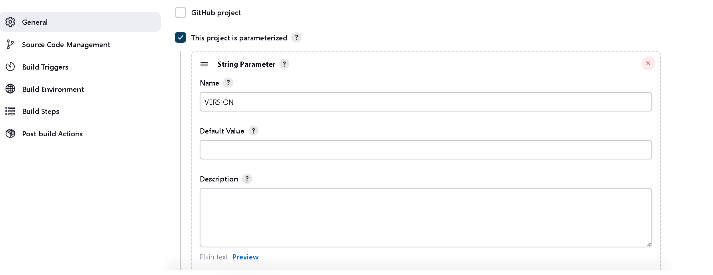

And make changes in execute shell command put $VERSION after vprofile
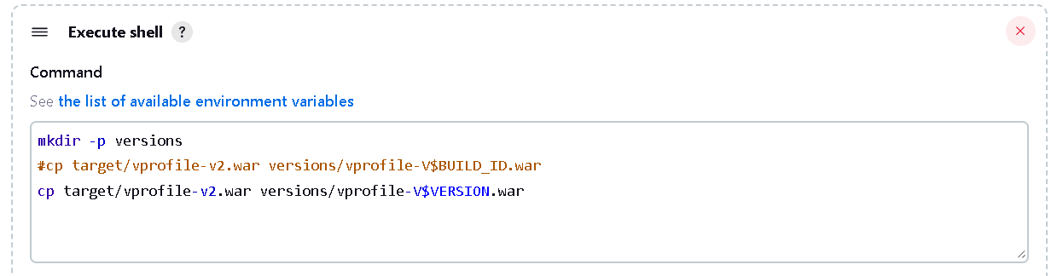
Now you will get option build with parameters
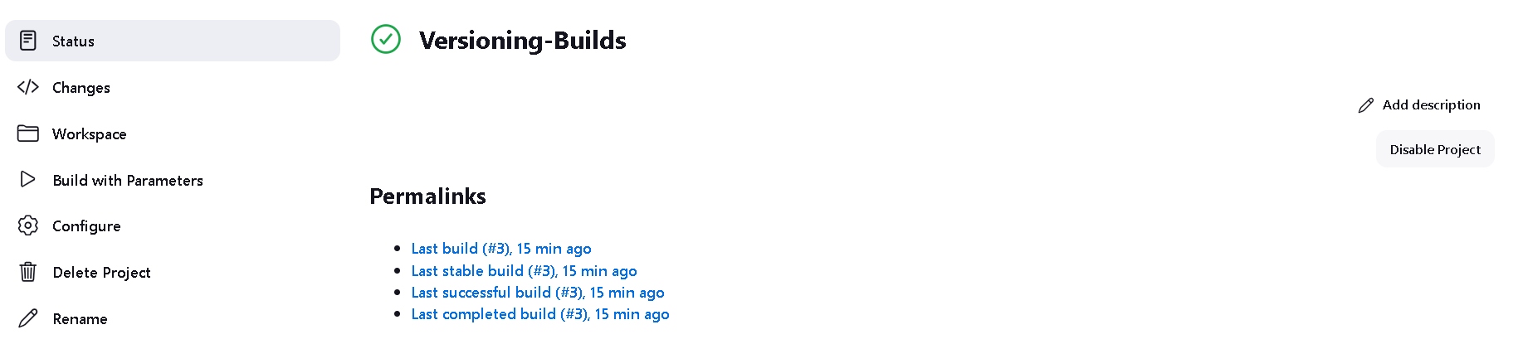
Now enter 4.1 version and hit build button
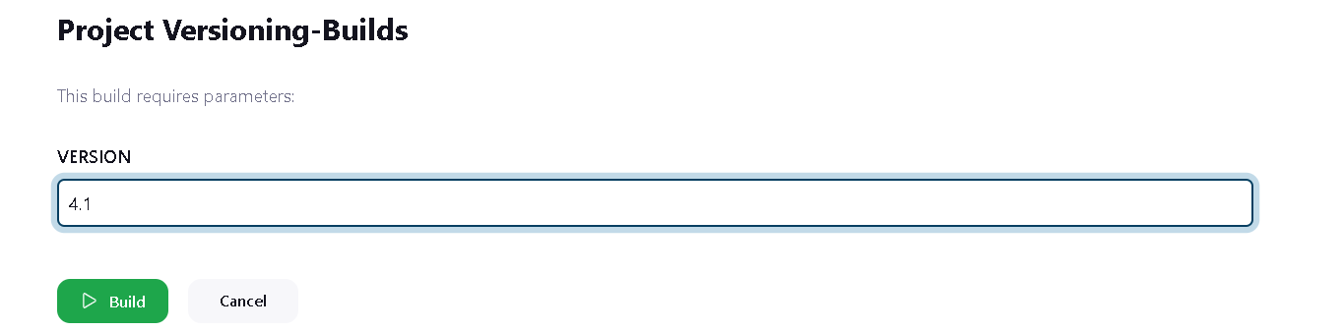
O/p now check the work space
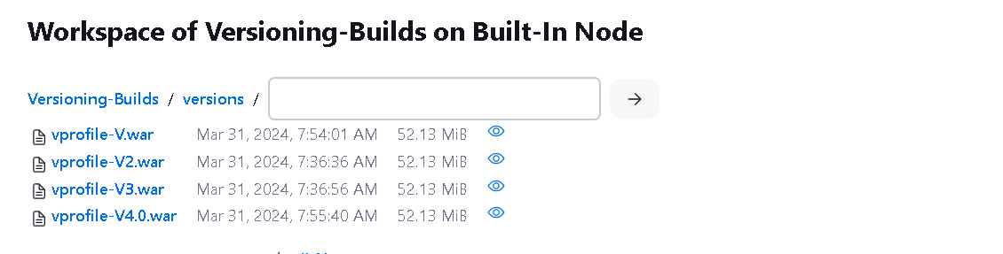

If you want proper versioning like date and time stamp so you can do like this

First install plugins for timestamp from manage Jenkins -> Plugins
In available plugin search timestamp and select any plugin we select Zentimestamp
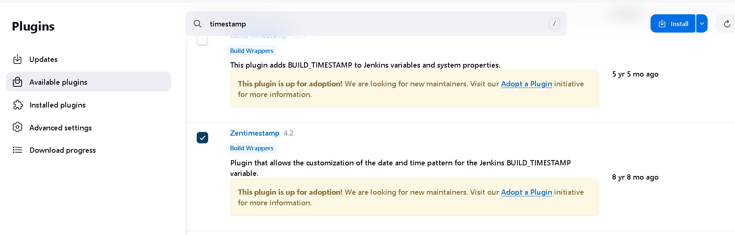

Now open pipeline and in Configuration section select General and uncheck this project is parameterized and checkmark the change date pattern for the BUILD_TIMESTAMP… and enter datetime pattern
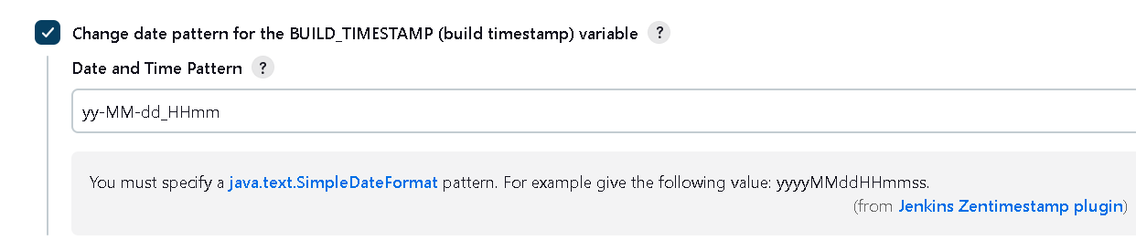

Also need to to changes in build script
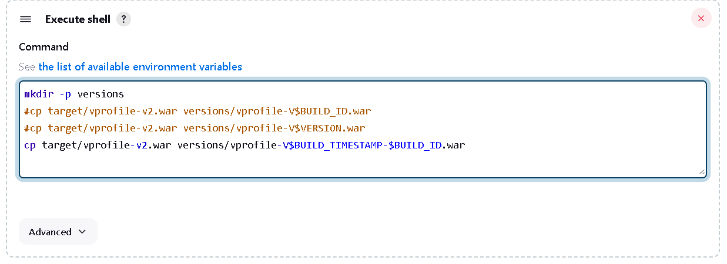
In work space
